ECOFLEX 0010 ENGINEERING PROPERTIES

* <https://flexlab.epfl.ch/wp-content/uploads/2017/12/39_2014_Terwagne_AdvMat_si.pdf> and <https://www.researchgate.net/publication/253020861_Hyperelastic_pressure_sensing_with_a_liquid-embedded_elastomer>

Ecoflex 0010 Shear Modulus G= 12.605 kPa, Poisson’s ratio = 0.4999

<https://pdfs.semanticscholar.org/bf0c/0c70a1db92d137f7c6b85a95c818deda6cb2.pdf>

Ecoflex 0010 Shear Modulus G= 10.5 kPa

* Y.-L. Park et al., ”Hyperelastic pressure sensing with a liquidembedded elastomer,” Journal of Micromech
* I. D. Johnston, D. K. McCluskey, C. K. L. Tan, and M. C. Tracey, ”Mechanical characterization of bulk Sylgard 184 for microfluidics and microengineering,” Journal of Micro
* <https://shan.blogs.unr.edu/files/2014/10/ICRA2013.pdf>

Ecoflex 0050 (Shore Hardness = 00- 50, 100% Tensile Modulus = 83 kPa)

Ecoflex 0010 (00-10, 55 kPa)

* <https://flexlab.epfl.ch/wp-content/uploads/2017/12/39_2014_Terwagne_AdvMat_si.pdf> - Process described, no results given
* <https://www.researchgate.net/publication/260773600_Inverse-FEM_Characterization_of_a_Brain_Tissue_Phantom_to_Simulate_Compression_and_Indentation> – Graph:

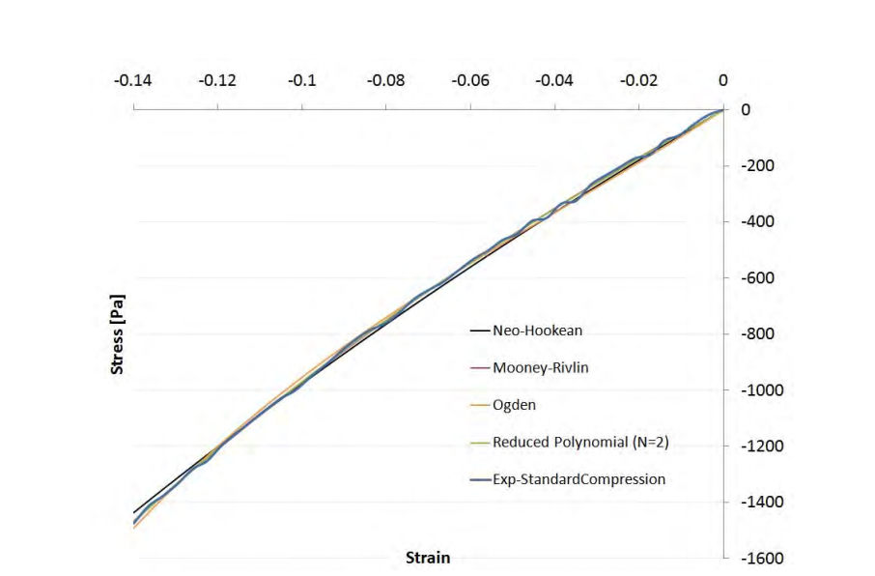

Elastic modulus 0010 = 8.4kPa.

Specific volume: 26.6 cu in/lb = 0.000960986 m3/kg

Therefore density = 1/0.000960986 = 1040.6 kg/m3

Uniaxial unconfined compression testing is a standardized method for evaluating the mechanical properties of compliant materials, such as polymers or soft tissues.14

Can do the FEA in Soildworks.

I need to add a reference geometry to do so. Good lord!!!